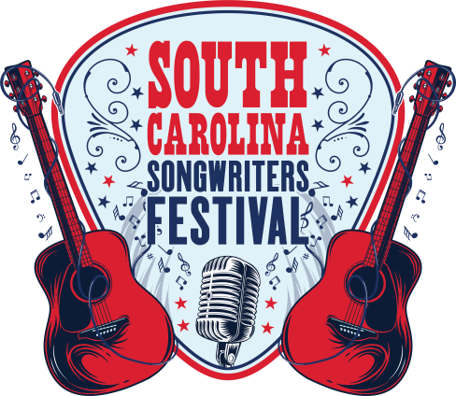
SONGWRITER INFORMATION FORM &
PARTICIPATION AGREEMENT

TODAY’S DATE: _______________________________________________________________________
SONGWRITER NAME: __________________________________________________________________
BAND (IF APPLICABLE) NAME: ___________________________________________________________
SONGWRITER ADDRESS: ________________________________________________________________
SONGWRITER CITY/STATE/ZIP: __________________________________________________________
SONGWRITER CONTACT NAME: __________________________________________________________
SONGWRITER TELEPHONE: ______________________________________________________________
SONGWRITER EMAIL: __________________________________________________________________
SONGWRITER WEBSITE: ________________________________________________________________
SONGWRITER RECORD LABEL: ___________________________________________________________
SONGWRITER PERFORMING RIGHTS ORGANIZATION: ________________________________________

SONGWRITER BIO:_____________________________________________________________________

Directions: Select the two hour block(s) that you would be willing to perform by writing the letter of the performing style (or styles) that you believe would fit your performing style from the list below:
Style A – Full band.
Style B – Songwriter Round. Multiple (2 to 6) songwriters, who perform in an acoustic style.
Style C – Individual acoustic performer.
 | Thursday  May 21, 2020 | Friday  May 22, 2020 | Saturday  May 23, 2020
2pm-4pm | Starts at 6pm | Starts at 6pm
4pm-6pm | Starts at 6pm | Starts at 6pm
6pm-8pm
8pm-10pm
10pm-12mid
12mid-2am

You are welcome to request multiple two hour blocks and multiple days; however, please note that this is a REQUEST form. By completing this form, you are requesting a slot(s) to perform. Performers and dates/times will be confirmed at a later date. All performances will be approximately 45-90 minutes.

Participation Agreement:
I hereby authorize Andrulonis Media and its radio stations to play my submissions on the air and/or via its radio streams or partners websites and waive my right to seek performance compensation pursuant to Sound Exchange, SESAC, ASCAP and BMI.
I confirm that I am at least 18 years of age or at least 16 years of age and my parent or legal guardian is filling out this form on my behalf.

- Venue provides backline, lighting, stage area that are appropriate to the Performing Style(s) selected in the schedule grid on the front of this Agreement.
- Bands receive food and drinks
- The performance must be free for attendees. Venue cannot charge a “cover charge” or other fee to attend.
- You also keep 100% of any merchandise sold, however, we appreciate that you have someone to watch your table and collect the funds. Venue cannot sell merchandise of the singer/songwriter without prior permission of the singer/songwriter.

X_____________________________________
Performer Signature and Date

