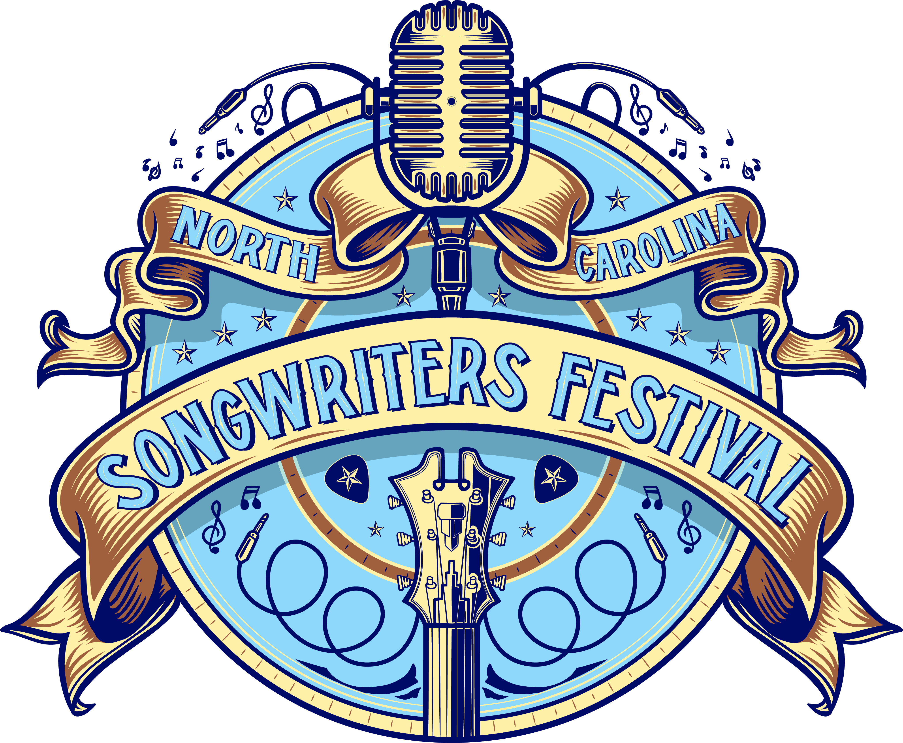

SONGWRITER INFORMATION FORM &
PARTICIPATION AGREEMENT

TODAY’S DATE: _______________________________________________________________________
NAME: __________________________________________________________________
BAND (IF APPLICABLE) NAME: ___________________________________________________________
ADDRESS: ________________________________________________________________
CITY/STATE/ZIP: __________________________________________________________
CONTACT NAME: __________________________________________________________
TELEPHONE: ______________________________________________________________
EMAIL: __________________________________________________________________
WEBSITE: ________________________________________________________________
RECORD LABEL: ___________________________________________________________
PERFORMING RIGHTS ORGANIZATION: ________________________________________

Opportunities to perform are limited. Submitting the application does not guarantee a slot in the festival.
You are welcome to request multiple two hour blocks and multiple days; however, please note that this is a REQUEST form. By completing this form, you are requesting a slot(s) to perform. Performers and dates/times will be confirmed at a later date. All performances will be approximately 45-90 minutes.

Directions: Select the two hour block(s) that you would be willing to host a performer by writing the letter of the performing style (or styles) that you believe would fit your venue from the list below:
Style A – Full band.
Style B – Individual acoustic performer.
Friday
May 6th, 2022
Saturday
May 7th, 2022

Participation Agreement:
I hereby authorize Colonial Radio Group and its radio stations to play my submissions on the air and/or via its radio streams or partners websites and waive my right to seek performance compensation pursuant to Sound Exchange, SESAC, ASCAP and BMI.
I confirm that I am at least 18 years of age or at least 16 years of age and my parent or legal guardian is filling out this form on my behalf.

X_____________________________________
Performer Signature and Date

